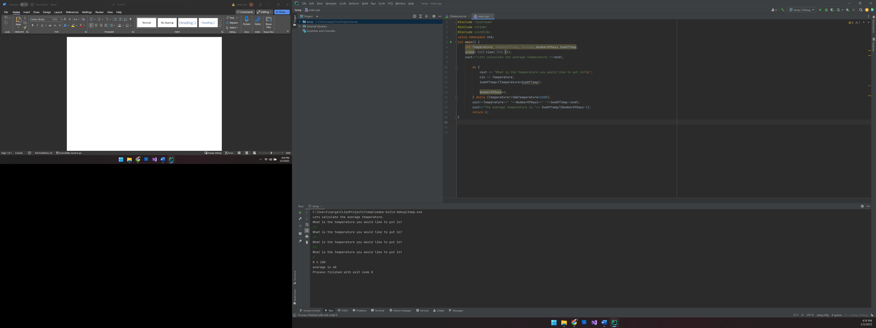

C:\Users\sarga\CLionProjects\temp\cmake-build-debug\temp.exe

Lets calculate the average temperature.

What is the temperature you would like to put in?

60

What is the temperature you would like to put in?

60

What is the temperature you would like to put in?

60

What is the temperature you would like to put in?

0

0 4 180

average is 60

Process finished with exit code 0#include <iostream>  
#include <ctime>  
#include <cstdlib>  
using namespace std;  
int main() {  
 int Temperature, NumberOfTemp, Average,NumberOfDays,SumOfTemp;  
 srand(time(0));  
 cout<<"Lets calculate the average temperature."<<endl;  
  
 do {  
 cout << "What is the temperature you would like to put in?\n";  
 cin >> Temperature;  
 SumOfTemp=(Temperature+SumOfTemp);  
  
 NumberOfDays++;  
 } while (Temperature!=0&&Temperature<1000);  
 cout<<Temperature<<" "<<NumberOfDays<<" "<<SumOfTemp<<endl;  
 cout<<"The average temperature is "<< SumOfTemp/(NumberOfDays-1);  
 return 0;  
}

C:\Users\sarga\CLionProjects\rain\cmake-build-debug\rain.exe

How much rain is going to fall in the 7 days?7

6

5

4

3

2

1

Here is how much Rain will fall 28

Process finished with exit code 0

#include <iostream>  
using namespace std;  
int main() {  
 int Days=7;  
 double RainFall,Rain;  
 cout<<"How much rain is going to fall in the 7 days?";  
 for (int i = 0; i <7 ; ++i) {  
 cin>>RainFall;  
 Rain=(RainFall+Rain);  
 }  
 cout<<"Here is the total rainfall "<< Rain;  
 return 0;  
}

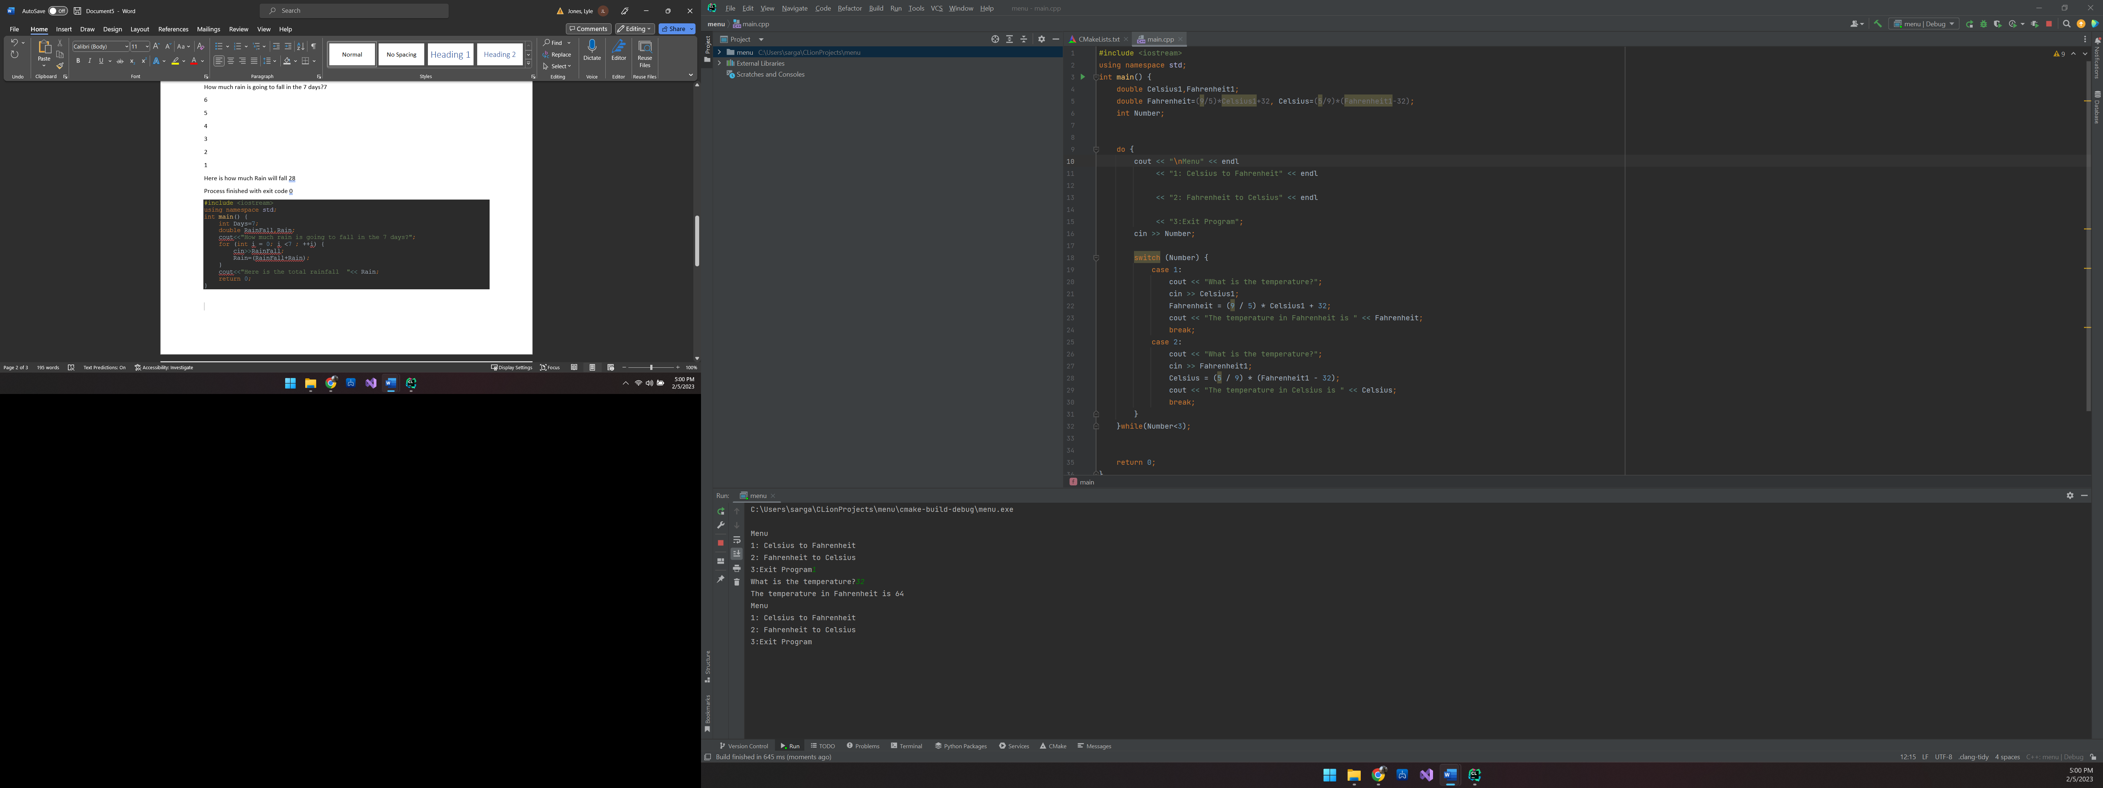

Menu

1: Celsius to Fahrenheit

2: Fahrenheit to Celsius

3:Exit Program1

What is the temperature?32

The temperature in Fahrenheit is 64

Menu

1: Celsius to Fahrenheit

2: Fahrenheit to Celsius

3:Exit Program

#include <iostream>  
using namespace std;  
int main() {  
 double Celsius1,Fahrenheit1;  
 double Fahrenheit=(9/5)\*Celsius1+32, Celsius=(5/9)\*(Fahrenheit1-32);  
 int Number;  
  
  
 do {  
 cout << "\nMenu" << endl  
 << "1: Celsius to Fahrenheit" << endl  
  
 << "2: Fahrenheit to Celsius" << endl  
  
 << "3:Exit Program";  
 cin >> Number;  
  
 switch (Number) {  
 case 1:  
 cout << "What is the temperature?";  
 cin >> Celsius1;  
 Fahrenheit = (9 / 5) \* Celsius1 + 32;  
 cout << "The temperature in Fahrenheit is " << Fahrenheit;  
 break;  
 case 2:  
 cout << "What is the temperature?";  
 cin >> Fahrenheit1;  
 Celsius = (5 / 9) \* (Fahrenheit1 - 32);  
 cout << "The temperature in Celsius is " << Celsius;  
 break;  
 }  
 }while(Number<3);  
  
  
 return 0;